NT7 Revelation and the Progress of Redemption
Dr. Marvin J. Effa
Revelation
Author: John, one of the close apostles of Jesus (Rev. 1:1, 1:4, 1:9, 22:8).
Date of writing: Rev. 1:9 states that John was banished to Patmos. Historical references indicate that this was in the15th year of Domitian (80-95 AD) and that he was released by Nerva in 96AD. Most modern scholars set the date near the end of his exile.
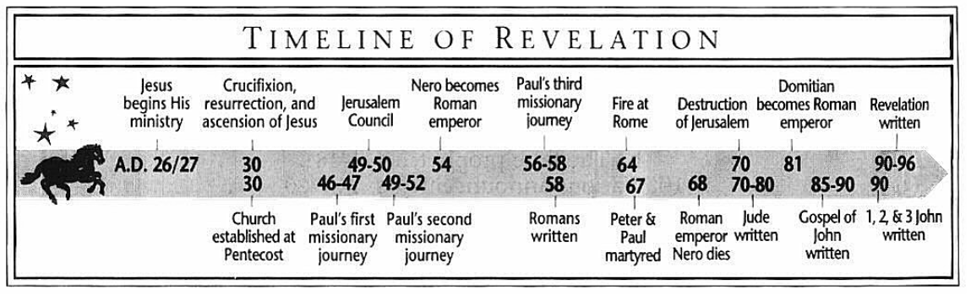
Purpose: While the majority of the book details the tribulation, which pertains to the nation Israel, it is stated that the message is intended to be delivered to the churches (Rev. 22:16). The book begins and ends with emphasis to the church. The book thus provides the chronological order of the Old Testament prophets and reminds the churches that God has not abandoned His plan for Israel.
Idea: Jesus reigns.
Development:
- Jesus reigns as judge among His churches, Rev. 1:1-20.
- Jesus demonstrates His knowledge and mastery of His churches, Rev. 2:1-3:22.
- The conclusion in heaven is that Jesus is qualified to reign on the earth, Rev. 4:1-5:14.
- The Seven Seal Judgements (parenthetical background information, Rev. 7), Rev.6:1-8:1.
- The Seven Trumpet Judgements (parenthetical information, Rev. 10-11:14), Rev. 8:2-11:19.
- Background information required to understand the judgements, Rev. 12:1-14:20.
- The Seven Bowl Judgements, Rev. 15:1-16:21.
- Judgement on Babylon, Rev. 17:1-18:24.
- The Second Coming, Rev.19:1-21.
- The millennium and the final rebellion, Rev. 20:1-10.
- The Great White Throne Judgement, Rev. 20:11-15.
- The New Heavens and Earth, Rev. 21:1-22:5.
- Christ is returning soon for His church, Rev. 22:6-21.
Key Passage Exegesis
- Are the 7 churches historical? Rev. 2-3.
- Who are the 144,000? Rev. 7.
- Who are the two witnesses? Rev. 11:1-14.
- What is the number of the Beast? Rev. 13:18.
- Understand the kings to understand Babylon 17-18.
- Who will be judged at the Great White Throne? Rev. 20:11-15.
- Are good works a requirement for participation in the New Heavens and Earth? Rev. 22.
